**Section One: Multiple-choice 30% (30 Marks)**

This section has **30** questions. Answer **all** questions on the separate Multiple-choice Answer Sheet provided. For each question, shade the box to indicate your answer. Use only a **blue or black pen** to shade the boxes. If you make a mistake, place a cross through that square, do not erase or use correction fluid, and shade your new answer. Marks will not be deducted for incorrect answers. No marks will be given if more than one answer is completed for any question.

Suggested working time: 40 minutes.

1. Below is a list of steps used in the amplification of DNA by the process of Polymerase Chain Reaction (PCR).
2. Decrease temperature to break hydrogen bonds
3. Increase temperature to separate DNA strands
4. Increase temperature to allow primers to anneal to template strands
5. Decrease temperature to allow primers to anneal to complementary strands
6. Increase temperature allowing DNA polymerase to add free nucleotides
7. Decrease temperature to allow DNA polymerase to replicate DNA

Which of the following identifies the **correct** order of steps for the process of PCR?

* 1. iii 🡪 i 🡪 vi
  2. iii 🡪 I 🡪 v
  3. ii 🡪 iv 🡪 v
  4. ii 🡪 iv 🡪 vi

1. The sodium-potassium pump works by pumping
   1. sodium ions into the cell and potassium ions out of the cell.
   2. both sodium and potassium ions into the cells.
   3. sodium ions out of the cell and potassium ions into the cell.
   4. both sodium and potassium out of the cells.
2. Sickle cell disease is caused by a defective single allele. Replacement of a defective allele with a normal allele is known as
   1. cell replacement therapy.
   2. gene therapy.
   3. DNA replacement therapy.
   4. cell cloning.
3. Which of the following transplant methods would prevent the body from eliciting an immune response? Use of
   1. organs from close relatives as they have similar identity markers.
   2. organs from monkeys as their DNA is very similar to humans.
   3. genetically engineered organs to remove identity markers.
   4. organs created from cloned cells of the patient.
4. The cells in the skin that detect the stimulus resulting in shivering, are examples of
   1. thermoreceptors.
   2. osmoreceptors.
   3. chemoreceptors.
   4. pain receptors.
5. A major function of the cerebellum is
   1. processing sensory and motor impulses for posture and coordination.
   2. transmitting sensory impulses to the cerebral cortex.
   3. controlling homeostatic functions of the body.
   4. forming speech and processing of shapes and symbols.
6. The refractory period is caused by
   1. inactivation of the voltage-gated sodium channels.
   2. inactivation of the voltage-gated potassium channels.
   3. hyperpolarisation due to the opening of the potassium channels.
   4. opening of the voltage-gated potassium and sodium channels.
7. When developing vaccines using the process of Recombinant DNA Technology, what is the name given to the circular piece of DNA removed and later reinserted in a bacterial cell?
   1. Mitochondria
   2. Vector
   3. Bacteriophage
   4. Plasmid
8. The extent to which a test is measuring its intended measurement is known as
   1. reliability.
   2. validity.
   3. sensitivity.
   4. controllability.
9. Which of the following sets of factors best represent those responsible for speciation?
   1. Gene mutation and genetic drift
   2. Gene mutation and heterozygote advantage
   3. Reproductive isolation and changes within a gene pool
   4. Reproductive isolation and genetic drift

Question 11 refers to the following diagram.

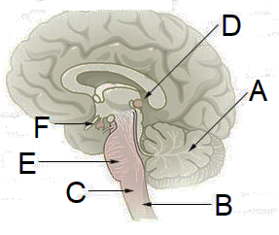

1. The endocrine organ located at position D is the
   1. pineal gland.
   2. hypothalamus.
   3. anterior pituitary gland.
   4. posterior pituitary gland.
2. The structure of the brain located at position C regulates which of the following homeostatic processes?
   1. Thermoregulation and body fluid concentrations
   2. Heart rate and breathing rate
   3. Blood sugar levels and thermoregulation
   4. Breathing rate and body fluid concentrations
3. Oxytocin, which is secreted from the posterior pituitary, is
   1. transported from the hypothalamus by a complex network of capillaries.
   2. produced in specialised cells located in the posterior pituitary.
   3. manufactured in special nerve cells in the hypothalamus.
   4. controlled by inhibiting and releasing factors.
4. Synthetic hormones differ from natural hormones in all of the following ways except that they
   1. are chemically altered to form a different shape from their natural hormone.
   2. are not metabolised as efficiently in the body.
   3. can cause severe side effects.
   4. act identically to the natural hormone they mimic.
5. Which of the following types of neurons best describes a neuron that has one axon and one dendrite, with multiple branches at their ends?
   1. Multipolar
   2. Bipolar
   3. Unipolar
   4. Pseudo-unipolar
6. The vagus nerve connects the medulla oblongata to cardiac muscle. The vagus nerve is attributed to the division of the nervous system known as the
   1. afferent nervous system.
   2. somatic nervous system.
   3. sensory nervous system.
   4. autonomic nervous system.
7. Which of the following is true of the nervous system and not of the endocrine system?
   1. Use of chemicals to send messages
   2. Regulated by negative feedback mechanisms
   3. Responses are temporary and reversible
   4. Cause changes in metabolic activities
8. Any damage to tissues stimulates an inflammatory response. Which of the following statements is **correct** in regards to inflammation?
   1. Cytokines (chemicals) are released from mast cells to increase phagocytic activity
   2. Release of heparin increases the permeability of the capillaries
   3. It brings about the stimulation of chemoreceptors.
   4. Macrophages and leucocytes passively engulf pathogens by endocytosis
9. Bioinformatics can be defined as the application of information technology to the study of evolutionary relationships at a
   1. cellular level.
   2. molecular level.
   3. atomic level.
   4. chemical level.
10. Which of the following pairs of chemoreceptor sites are stimulated by low levels of oxygen?
    1. Aortic and carotid bodies.
    2. Central and peripheral chemoreceptors.
    3. Peripheral chemoreceptors and the respiratory centre.
    4. Receptors in the medulla oblongata and nasal passages.

Question 21 to 22 refers to the graph shown below.

1. Given the information in the graph, how many years old is a sample when 35% of potassium-40 is remaining?
   1. 2.6 billion years old
   2. 1.9 billion years old
   3. 1.3 billion years old
   4. 1.0 billion years old
2. Which of the following statements best explains why 100 000 years is the lowest limit of the potassium-argon dating method for determining the age of rocks?
   1. Fossils older than 100 000 years have too much potassium contamination from environmental disasters for accurate measurement.
   2. The half-life of potassium-40 is long and so, at 100 000 years, there is too little argon-40 to measure.
   3. The proportion of potassium in the rock is not known beyond 100 000 years ago.
   4. After 100 000 years, there is too little potassium left in the rock.
3. An antimicrobial is any agent that kills or stops the growth of bacteria and viruses. Antimicrobial agents **do not** work by
   1. inhibition of cell wall synthesis.
   2. inhibition of DNA replication.
   3. interference with the structure of the cell membrane.
   4. increased production of enzymes.
4. The type of immunity gained by a foetus through the placenta during pregnancy is known as
   1. natural, passive immunity.
   2. natural, active immunity.
   3. artificial, passive immunity.
   4. artificial, active immunity.

Question 25 refers to the diagram below.

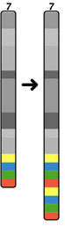

1. The type of mutation depicted above is known as
   1. a deletion.
   2. an inversion.
   3. a duplication.
   4. a translocation.
2. Survival of the fittest occurs when the environment acts on the individual’s
   1. genotype.
   2. alleles.
   3. phenotype.
   4. genotype and phenotype.

Question 27 refers to the diagram below that represents the theory of evolution by natural selection of a population for dark colouration.

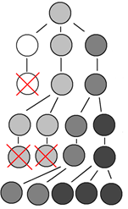

A →

1. Which of the following principles of evolution through natural selection does row A on the diagram illustrate?
   1. Survival of the fittest occurs, where better suited individuals survive.
   2. Favourable characteristics are passed onto the next generation.
   3. There is variation of characteristics within a species.
   4. More offspring of a species are produced than can be supported.
2. Three measurements of a student’s height were taken in centimetres and are recorded below.

|  |  |  |
| --- | --- | --- |
| 133.5 | 134 | 133.8 |

This uncertainty in measurement is best described as

* 1. measurement error.
  2. random error.
  3. systematic error.
  4. parallax error.

1. The heights of the 11 other students in the class were measured in centimetres and are shown below.

134 135 124 138 142 129 131 128 124 133 127

The measurement of 129 cm best represents the

1. mean.
2. mode.
3. median.
4. range.

(Median Is 131)

Question 30 refers to the diagram below.

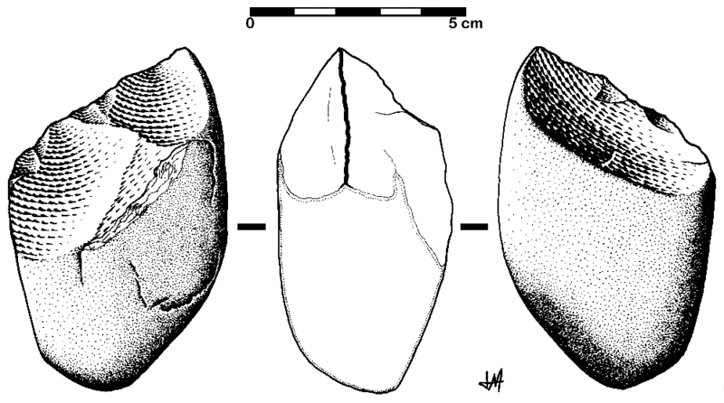

1. The tool shown above is most likely associated with
   1. *Homo neanderthalensis.*
   2. *Homo sapiens.*
   3. *Homo erectus.*
   4. *Homo habilis.*

**Section Two: Short Answer 50% (105 Marks)**

This section has **eight (8)** questions. Answer **all** questions. Write your answers in the spaces provided.

Additional working space pages at the end of the Question/Answer booklet are for planning or continuing an answer. If you use these pages, indicate at the original answer, the page number it is planned/continued on and write the question number being planned/continued on the additional working space page.

Suggested working time: 90 minutes.

**Question 31 (13 marks)**

Baker’s yeast contains genes for DNA repair that are very similar to humans; however, some strains have mutations that prevent them from repairing their DNA and result in cell death. This sensitivity to DNA damage allows the effect of Sun Protection Factor (SPF) on protection from Ultraviolet radiation (UV) to be assessed.

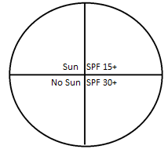

Students divided the base and lid of a Petri dish into 4 sections and labelled them as shown in the diagram above. 1mL of UV-sensitive yeast solution was placed on the agar in the Petri dish and tilted until the entire agar was covered. The lid of the Petri dish was taped to the base, ensuring the lines were aligned. Sunscreen of the appropriate SPF was smeared on the lid of the marked areas, whilst the area marked ‘Sun’ was left untouched and black paper was placed over the section labelled ‘No Sun’. The Petri dish was then exposed to a UV light for 5 minutes. After this time, the sunscreen was removed from the lid and the yeast allowed to grow for 48 hours at 30℃. The percentage of the area containing yeast growth was recorded and the results are shown in the table on page 12.

|  |  |  |  |  |
| --- | --- | --- | --- | --- |
| **Condition** | **Sun** | **No Sun** | **SPF 15+** | **SPF 30+** |
| **Yeast Growth (%)** | 15 | 94 | 37 | 74 |

1. Graph these results on the grid paper below. (5 marks)

A spare grid is located at the end of this booklet.

|  |  |
| --- | --- |
| **Description** | **Mark** |
| Correctly constructs axes using appropriate scales. | 1 |
| Correct plots points using a column graph with gaps between conditions (i.e. not continuous data) | 1 |
| Labelling of axes with correct name and unit | 1 |
| Identifies conditions using keys/labels | 1 |
| Title appropriate with both independent and dependent variables included (independent = sun protection; dependent = yeast growth) | 1 |
| **Total** | **5** |

1. Propose an appropriate hypothesis for this investigation. (1 mark)

|  |  |
| --- | --- |
| **Description** | **Mark** |
| As SPF increases, yeast growth increases.  (Must relate independent variable to dependent variable) | 1 |
| **Total** | **1** |
|  |  |

1. Explain why one section of the Petri dish did not contain any sunscreen.

(2 marks)

|  |  |
| --- | --- |
| **Description** | **Mark** |
| To use as a comparison / control | 1 |
| To determine baseline conditions / amount of yeast growth with no SPF/Sunscreen protection | 1 |
| **Total** | **2** |

1. State **one** change to the method of this investigation that would increase the reliability of the results. (1 marks)

|  |  |
| --- | --- |
| **Description** | **Mark** |
| Repetition / Replication / Larger Sample Size | 1 |
| **Total** | **1** |

1. For this experiment to be valid for humans, it should be tested on human participants. Explain **two** principles that would need to be considered to ensure the investigation would be ethically sound. (4 marks)

|  |  |
| --- | --- |
| **Description** | **Mark** |
| Any two of the following for 2 marks each. |  |
| * Voluntary participation – no pressure for subject to be involved | 1-4 |
| * Informed consent – participants should be away of all information about the investigation |
| * Risk of harm – should be little-no/minimised risk of physical or psychological harm |
| * Confidentiality – identities of the participants should not be revealed to anyone outside the investigation |
| **Total** | **4** |

**Question 32 (11 marks)**

Parts (a), (b) and (c) of the following question refer to the diagram of a healthy brain compared to a brain suffering from Alzheimer’s disease shown below.

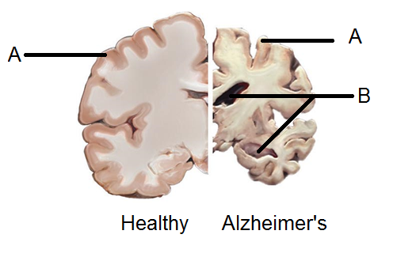

1. State the name of the matter found at the locations labelled A. (1 mark)

|  |  |
| --- | --- |
| **Description** | **Mark** |
| Grey matter | 1 |
| **Total** | **1** |

1. State **one** change that can be seen between the healthy and Alzheimer’s affected brain. (1 mark)

|  |  |
| --- | --- |
| **Description** | **Mark** |
| Any one of the following for one mark: |  |
| * Cerebral Cortex / Cerebrum, shrivels up/reduces in size * Hippocampus reduces in size/shrivels up * Ventricles/fluid-filled areas of the brain increase in size/grow larger | 1 |
| **Total** | **1** |

1. Repetitive questions and conversations are a common sign of Alzheimer’ Disease. Suggest how damage to the outer areas of the brain would cause this to occur. (3 marks)

|  |  |
| --- | --- |
| **Description** | **Mark** |
| Damage to the association areas/temporal lobe/frontal lobe | 1 |
| Severs the links/connections between nerve pathways | 1 |
| (which are) associated with memory | 1 |
| **Total** | **3** |

1. Alzheimer’s disease is also associated with dysfunctional autonomic nervous systems. Compare and contrast the somatic and autonomic nervous systems.

(3 marks)

|  |  |
| --- | --- |
| **Description** | **Mark** |
| One similarity for 1 mark from the following: |  |
| * Acetylcholine used * Excitatory capabilities * Receive input from sensory neurons | 1 |
| Two differences for 1 mark each from the following rows:   |  |  | | --- | --- | | **Somatic** | **Autonomic** | | Effector: skeletal muscle | Effector: smooth and cardiac muscle and glands | | Voluntary | Involuntary | | One motor neuron | Two motor neurons | | No use of epinephrine | Use of epinephrine | | No inhibitory capability | Inhibitory capability | | 1-2 |
| **Total** | **3** |

1. There is currently no cure for Alzheimer’s disease; however, cell replacement therapy has the potential to treat such nervous system disorders. Explain the process of cell replacement therapy in the context of Alzheimer’s disease. (3 marks)

|  |  |
| --- | --- |
| **Description** | **Mark** |
| Stem cells are isolated | 1 |
| (stem) cells are cultured/grown ex-vivo | 1 |
| Cells are reintroduced into damaged areas of the brain | 1 |
| **Total** | **3** |

**Question 33 (13 marks)**

An increasing number of young patients have been diagnosed with severe intestinal infections. Scientists believe that the microorganism responsible has a high rate of mutation and has shown resistance to common antibiotic treatments.

1. State the most likely microorganism associated with the intestinal infection.

(1 mark)

|  |  |
| --- | --- |
| **Description** | **Mark** |
| Bacteria | 1 |
| **Total** | **1** |

1. State and briefly describe the process by which this microorganism gains antibiotic resistance. (4 marks)

|  |  |
| --- | --- |
| **Description** | **Mark** |
| Natural Selection | 1 |
| Some bacteria show (antibiotic) resistance | 1 |
| Antibiotics kill ‘normal’ bacteria / do not kill resistance bacteria | 1 |
| Resistant bacteria multiply/grow | 1 |
| **Total** | **4** |

1. Since it is difficult to cure the intestinal infection caused by this organism, explain how the spread of this infection can be prevented in others by using synthetic means.

(3 marks)

|  |  |
| --- | --- |
| **Description** | **Mark** |
| Vaccine/Vaccination | 1 |
| Any two of the following for 1 mark each: |  |
| * Use of weakened/attenuated pathogen and/or dead pathogen * Ability to manufacture antibodies / creates memory cells * Artificial active immunity | 1-2 |
| * Herd immunity |  |
| * Or Wash hands – prevent via direct contact * Don’t share water bottles/utensils – ingestion * Prevent Sharing of body fluids – gloves * Disinfect surfaces |  |
| **Total** | **3** |

1. Pathologists were able to observe the cells of the patients and saw them to be infected with the microorganism. Draw a flowchart, or annotated diagram, to demonstrate the appropriate response of the immune system. (5 marks)

|  |  |
| --- | --- |
| **Description** | **Mark** |
| Flowchart/annotated diagram must include any five of the following for 1 mark each: |  |
| * T-cells in lymphoid tissue * T-cell is presented with antigen from B-cell / macrophage * T-cell is sensitised/activated * T-cell enlarges * T-cell divides / Clones of T-cells are produced * T-cells become Killer T-cells, Helper T-cells, memory cells | 1-5 |
| Example: | |
| **Total** | **5** |

**Question 34 (11 marks)**

The following question refers to the diagrams below that show Sanger’s method of DNA Sequencing when undertaking comparative genomics.

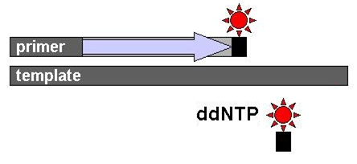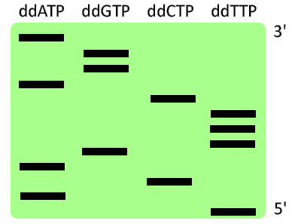

1. Explain the importance of the dideoxynucleotide (ddNTP) in this technique. (3 marks)

|  |  |
| --- | --- |
| **Description** | **Mark** |
| Stops/terminates chain elongation / chain-elongation inhibitors / don’t allow other nucleotides to be added | 1 |
| Lack OH/hydroxyl group | 1 |
| Allow the strands to be compared | 1 |
| **Total** | **3** |

1. State the sequence of bases of DNA in a 5’ to 3’ direction. (1 mark)

|  |  |
| --- | --- |
| **Description** | **Mark** |
| TAC AGT TTC AGG A | 1 |
| **Total** | **1** |

1. DNA Sequencing, and other associated techniques, have allowed for comparative studies of DNA. Explain how comparing nuclear DNA sequences can provide evidence for evolution. (3 marks)

|  |  |
| --- | --- |
| **Description** | **Mark** |
| Species have different DNA sequences/codes | 1 |
| Use of hybridisation/ERVs/non-functional (junk) DNA | 1 |
| The more similarities in DNA, the closer the relation / the greater the differences, the more distant relation | 1 |
| **Total** | **3** |

1. Suggest **two** reasons why mitochondrial DNA (mtDNA) is best used when comparing individuals within a species. (2 marks)

|  |  |
| --- | --- |
| **Description** | **Mark** |
| Any two of the following: |  |
| * mtDNA is inherited from the mother * Lack of recombination * Higher mutation rate * Higher copy number | 1-2 |
| **Total** | **2** |

Comparative evidence has shown approximately 20% of *Homo sapiens* DNA is shared with *Homo neanderthalensis*. Both physical characteristics and cultural behaviours of these two hominins have evolved, allowing the species to become more suited to the environment.

1. With respect to biological evolution and cultural evolution, identify which occurs faster and explain why.

(2 marks)

|  |  |
| --- | --- |
| **Description** | **Mark** |
| Cultural evolution is faster | 1 |
| Culture is not inherited / culture is passed on through learning / culture can be shared among many people | 1 |
| **Total** | **2** |

**Question 35 (14 marks)**

The following question refers to the graph below of a Year 12 student’s glucose levels during the course of a day.

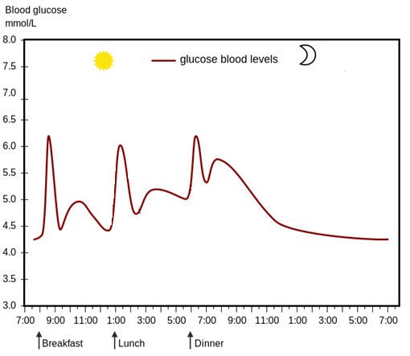

1. Explain why you would expect the insulin levels to increase when blood glucose levels do, and give **two** reasons for the fall in blood glucose after eating a meal. (5 marks)

|  |  |
| --- | --- |
| **Description** | **Mark** |
| Any three of the following for 1 mark each: |  |
| * Increased levels of glucose stimulate insulin release * Chemoreceptors in the Islets of Langerhans * Islets of Langerhans are located in Pancreas * Beta cells produce insulin * Causes a decrease in blood glucose | 1-3 |
| Any two of the following for 1 mark each: |  |
| * Increases glucose uptake into body/liver cells * Conversion to fatty acids/promotes fat storage * Promotes glycogenesis/conversion of glucose to glycogen * Used for respiration/glycolysis/metabolic activity | 1-2 |

1. At approximately 10.30am, the Year 12 student went for a brisk walk. State the name of the adrenal hormone that is produced in the cortex and describe the impact this hormone has on blood glucose levels. (3 marks)

|  |  |
| --- | --- |
| **Description** | **Mark** |
| Glucocorticoids/Cortisol | 1 |
| Stimulates glycogenolysis/stimulate breakdown of glycogen in liver and release of glucose into blood | 1 |
| Gluconeogenesis | 1 |
| **Total** | **3** |

1. Describe how the graph illustrates the concept of negative feedback. (2 marks)

|  |  |
| --- | --- |
| **Description** | **Mark** |
| Rise in blood glucose levels is a movement away from the norm | 1 |
| Release of insulin reduces/eliminates the original stimulus | 1 |
| **Total** | **2** |

Diabetes is a chronic condition that results in sufferers having high blood glucose levels, frequent urination and constant feelings of thirst.

1. State the effect of high blood glucose levels on osmotic pressure of the blood.

(1 mark)

|  |  |
| --- | --- |
| **Description** | **Mark** |
| Increases | 1 |
| **Total** | **1** |

1. Using the thirst mechanism, explain why diabetes sufferers experience constant feelings of thirst. (3 marks)

|  |  |
| --- | --- |
| **Description** | **Mark** |
| Osmoreceptors detect increased osmotic pressure | 1 |
| Stimulation of thirst centre makes the person feel thirsty | 1 |
| Conscious feeling of thirst stimulates person to drink | 1 |
| **Total** | **3** |

**Question 36 (13 marks)**

The following question refers to the diagram of the hand of a chimpanzee.

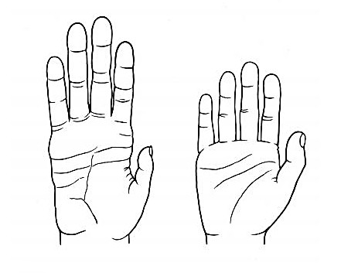

1. State **one** feature of the hand of this primate that would differ from that of a *Homo sapien*, and identify the evolutionary trend from the Great Ape family to Homo’s that is associated with this feature. (2 marks)

|  |  |
| --- | --- |
| **Description** | **Mark** |
| Any one of the following for 2 marks: |  |
| * Less mobility of digits * Increasing mobility/ability to move digits independently of one another | 1-2 |
| * Less opposability of digits/Shorter thumb(or first digit) * Increased opposability/increased length in thumb(or first digit) | 1-2 |
| * Longer and/or curved fingers / lower second to fourth digit ratio * No longer arboreal/no need to live/swing in tree canopies | 1-2 |
| * Longer and/or skinnier palm * Increased opposability/move towards precision grip | 1-2 |
| **Total** | **2** |

The pelvis of a female *Homo sapiens* is shown in the diagram below.

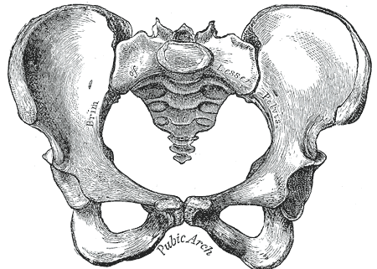

1. Contrast **three** differences between the pelvis of a *Homo sapiens* and a *Homo habilis.* (3 marks)

|  |  |
| --- | --- |
| **Description** | **Mark** |
| Pelvis is shorter in *sapiens* and longer in *hablis* | 1 |
| Pelvis is broader/more bowl shaped in *sapiens* and narrower in *habilis* | 1 |
| Femur attachment is more angled in *sapiens*  and more vertical in *habilis* | 1 |
| **Total** | **3** |

1. Describe how the features identified in part (b) are associated with the increased ability to walk upright. (3 marks)

|  |  |
| --- | --- |
| **Description** | **Mark** |
| * Increased carrying angle/more efficient locomotion due to less sway/striding gait improved balance/increased stability when walking/weight distribution remains central * Changes position of muscle attachment/allows attachment of larger muscles * Supports internal organs/foetus when standing erect | 1-3 |
| **Total** | **3** |

1. Besides the ability to walk in a bipedal manner, state **one** other reason for the evolutionary trend seen in the pelvis. (1 mark)

|  |  |
| --- | --- |
| **Description** | **Mark** |
| Offspring are born with larger brains/heads | 1 |
| **Total** | **1** |

1. Fossils of *Homo neanderthalensis* have been found in Germany and throughout Europe. Beside the features of the skull, state **two** anatomical features of Neanderthals and discuss how selection pressures have acted on the species.

(4 marks)

|  |  |
| --- | --- |
| **Description** | **Mark** |
| Any two of the following: |  |
| * Short stature * Thick necks * Short limbs * Powerful muscles * Barrel shaped chest | 1-2 |
| assisted in hunting big game | 1 |
| survival in the harsh conditions/ice ages of Europe | 1 |
| **Total** | **4** |

**Question 37 (12 marks)**

1. State the relationship between cranial capacity and evolution of tools as seen in hominins. (1 mark)

|  |  |
| --- | --- |
| **Description** | **Mark** |
| Tool development is associated with increased cranial capacity/intellect | 1 |
| **Total** | **1** |

Three of the main hominin tool cultures are, Acheulean, Oldowan, and Mousterian.

1. Complete the table by identifying the hominin associated with the tool culture. (3 marks)

|  |  |  |
| --- | --- | --- |
| Approximate Age Range | Tool Culture | Associated hominin |
| 200 000 – 40 000 years | Mousterian | H Neanderthalensis (1) |
| 2.6 – 1.7 million years | Oldowan | Homo habilis (1) |
| 1.7million years – 200 000 years | Acheulian | H erectus (1) |

1. In the space below, create a phylogenetic tree that depicts the three hominin species associated with the tool cultures above. (2 marks)

|  |  |
| --- | --- |
| **Description** | **Mark** |
| Must include:   * Branches representative of evolutionary time/or time scale included * *H. habilis, H. erectus, H. Neanderthalensis* in order | 1-2 |

1. Identify **two** trends seen in the tool cultures over time. (2 marks)

|  |  |
| --- | --- |
| **Description** | **Mark** |
| Two of the following for 1 marks each: |  |
| * increasing refinement/more finely worked/more delicate objects made * increased number of blows/flakes * increase in the variety of materials used * tools became more specific for their use * increased time taken to make the tools | 1-2 |
| **Total** | **2** |

1. Describe how the manufacturing of Acheulian tools may have influenced the social structure of the species associated with that tool culture.

(2 marks)

|  |  |
| --- | --- |
| **Description** | **Mark** |
| Any two of the following for 1 mark each: |  |
| * Mutual cooperation/cooperative group activities * Men hunted and women gathered * Spoken languages may have been present/improved communication * Use of a home base | 1-2 |
| **Total** | **2** |

1. Explain **one** adaptive advantage to the hominins way of life by using tools of the Magdalenian culture over the tools of the Oldowan culture. (2 marks)

|  |  |
| --- | --- |
| **Description** | **Mark** |
| One of the following for 2 marks: |  |
| * Production of needles / evidence of stitching * Improved protection through clothing | 1-2 |
| * Production of varied hunting tools * Wider diet | 1-2 |
| * Production of tools for fishing * Exploitation of coastal areas/waterways | 1-2 |
| **Total** | **2** |

**Question 38 (18 marks)**

Respiratory infections are a leading cause of seeking medical care in returning travellers. Due to enclosed spaces on aeroplanes, close proximity to contagious people is common.

1. Explain how droplets can spread respiratory infections. (3 marks)

|  |  |
| --- | --- |
| **Description** | **Mark** |
| Pathogen is housed within droplet | 1 |
| Droplets are emitted when breathing/talking/sneezing/coughing | 1 |
| Droplet comes is breathed in/droplet is ingested | 1 |
| **Total** | **3** |

1. Identify and describe **two** external defence mechanisms of the respiratory tract that would help prevent pathogens from entering the body. (4 marks)

|  |  |
| --- | --- |
| **Description** | **Mark** |
| Any two of the following for 2 marks each: |  |
| * Hairs within the nose cavity * Trap pathogens | 1-2 |
| * Cilia/tiny hair-like projections from cells line airways * Movement of cilia moves pathogens towards throat | 1-2 |
| * Lysozyme found in nose secretions * Kill bacteria | 1-2 |
| * Mucous membranes * Secrete mucus that traps pathogens | 1-2 |
| **Total** | **4** |

Upon seeking medical assistance, the doctor undertook a reflex test as demonstrated in the diagram below.

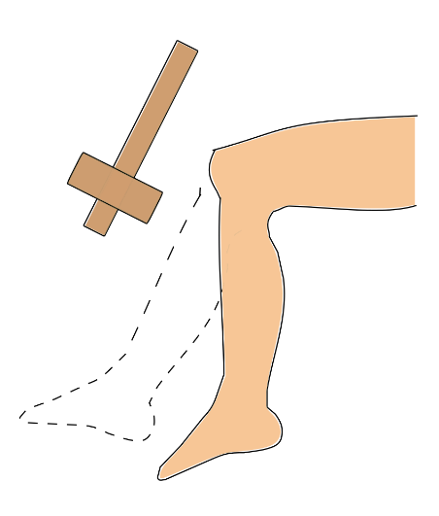

1. Explain the pathway of a spinal reflex. Ensure your answer refers to the neurons involved in the pathway. (5 marks)

|  |  |
| --- | --- |
| **Description** | **Mark** |
| Receptors detect the stimulus | 1 |
| Sensory neuron conducts nerve impulse/message from receptor to spinal cord | 1 |
| Information is processed in the CNS/Passes across a synapse. One or more interneurons pass impulse/message to motor neurons | 1 |
| Motor neuron carries message/impulse to effector | 1 |
| Effector carries out appropriate response | 1 |
| **Total** | **5** |

Whilst undertaking a medical assessment, the doctor noticed the patient had low concentrations of hormones and diagnosed hypopituitarism, or partial loss of the anterior pituitary.

1. State and describe the effect of **two** of the hormones that would be affected by hypopituitarism. (4 marks)

|  |  |
| --- | --- |
| **Description** | **Mark** |
| Any two of the following for 2 marks each: |  |
| * FSH/Follicle Stimulating Hormone * Stops the development of the follicles | 1-2 |
| * Luteinising hormone/LH * Stops ovulation/forms corpus luteum/stimulates interstitial cells in the testes | 1-2 |
| * Growth hormone * Reduces body growth/reduces rate at which amino acids are taken up by cells/maintains size of organs once mature | 1-2 |
| * Thyroid-stimulation hormone * Reduces production AND release of hormones from thyroid | 1-2 |
| * Adrenocorticotropic hormone/ACTH/Adrenocorticotropin * Reduces the production AND release of hormones from cortex of adrenal glands | 1-2 |
| * Prolactin/PRL/lactogenic hormone * Reduced and maintain milk secretion | 1-2 |
| **Total** | **4** |

1. Describe why releasing and inhibiting factors from the hypothalamus are classified as hormones themselves. (2 marks)

|  |  |
| --- | --- |
| **Description** | **Mark** |
| Secreted into extracellular fluid (surrounding hypothalamus) | 1 |
| Transported by the blood | 1 |
| **Total** | **2** |

**Section Three: Extended answer 20% (40 marks)**

This section has **three (3)** questions. You must answer **two (2)** questions. Write your answers on the lined pages provided.

Supplementary pages for the use of planning/continuing your answer to a question have been provided at the end of this Question/Answer booklet. If you use these pages to continue an answer, indicate at the original answer where the answer is continued, i.e. give the page number.

Responses could include clearly labelled diagrams with explanatory notes; lists of points with linking sentences; clearly labelled tables and graphs; and annotated flow diagrams with introductory notes.

Suggested working time: 50 minutes.

Answer any **two (2)** questions from Questions 39 to 41.

Indicate the questions you will answer by ticking the box next to the question. Write your answers on pages that follow.

**Question 39 (20 marks)**

1. *Homo habilis* is a debated species, with some scholars stating that the species fits more into the genus of Australopithecus, rather than Homo. Contrast **six** features of the torso and body limbs between the genus of Homoand Australopithecus.

(6 marks)

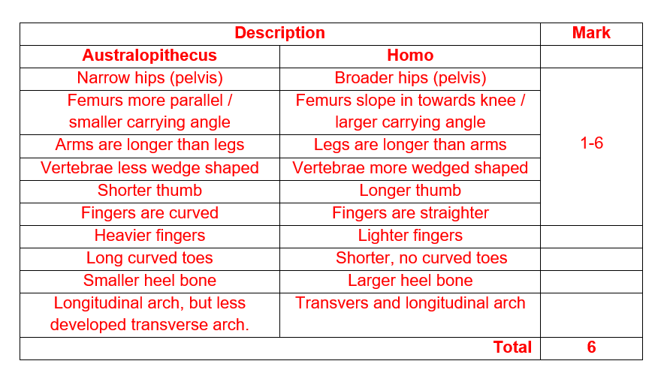

In 2013, palaeontologists uncovered fossils of a large dinosaur in Winton, Queensland. The fossils are said to be of those living within the cretaceous period, 100 million years ago.

1. Explain **four** conditions that would have occurred to fossilise these bones.

(8 marks)

|  |  |
| --- | --- |
| **Description** | **Mark** |
| (Conditions) Any four for up to 2 marks each: |  |
| * Alkaline soils / not acidic soils * Bones are not dissolved | 1-2 |
| * Geologically stable area over a long period of time * Lower chance of fossil being destroyed | 1-2 |
| * Rapid burial * Lack of oxygen * To stop decomposition | 1-2 |
| * Undisturbed by animals / humans * Lower chance of fossil being destroyed | 1-2 |
| * Water based environment * Quick deposition of sediments | 1-2 |
| **Total** | **8** |

1. State and describe the most appropriate absolute and **one** relative dating method that could be used to age these bones. (6 marks)

|  |  |
| --- | --- |
| **Description** | **Mark** |
| Absolute – Potassium-Argon dating | 1 |
| * Potassium-Argon dating * Dates beyond 100 000 – 200 000 years old * Dates the rock/volcanic rock not the bone * Based on ratio of Potassium-40 to Argon-40 * Half-life of 1.25-1.3 billion years | 1-2 |
| (Relative) Any one of the following: |  |
| * Stratigraphy * Principle of superposition * Layers of rock at the top are younger than those at the bottom | 1 |
| 1-2 |
| * Stratigraphy * Correlation of rock strata * Use of index fossils to compare/correlate strata from different locations | 1 |
| 1-2 |
| **Total** | **6** |

**Question 40 (20 marks)**

Fear is a distressing emotion that is aroused in situations of impending danger. Frightening stimuli stimulate a chain reaction in the brain, triggering a fight-or-flight response. In some cases, such as anxiety, these responses are more frequent and persistent often resulting in increased sweating.

1. Not including increased sweat production, state **four** of the fight-or-flight responses and describe how each of these responses is important in preparing the body. (8 marks)

|  |  |
| --- | --- |
| **Description** | **Mark** |
| Any four for up to 2 marks each: |  |
| * Increased heart rate * Pumps more blood around the body so that nutrients are delivered to the skeletal muscles | 1-2 |
| * increased breathing rate/bronchodilation * delivers more oxygen to the blood so it can be taken to the skeletal muscles | 1-2 |
| * vasoconstriction in organs not involved in activity/internal organs/kidney/stomach/intestines/skin * shifts blood to the skeletal muscles / less likely to bleed to death if injured | 1-2 |
| * vasodilation in skeletal muscles * increases blood flow to the skeletal muscles for activity | 1-2 |
| * decreased peristalsis/movement in stomach/intestines / decreased production of saliva * non-essential physiological processes stop / shifts blood to more important skeletal muscles | 1-2 |
| * dilated pupils * to allow more light in and/or improve sight | 1-2 |
| * blood glucose levels rise / liver converts glycogen to glucose * increased production of energy/ATP | 1-2 |
| * Increased adrenaline/noradrenaline levels / increase secretion of hormones from adrenal medulla * Intensify and prolong responses / increase glucose levels | 1-2 |
| **Total** | **8** |

Psychiatrists often suggest anxiety sufferers should have a cool shower when they are experiencing symptoms, such as sweating.

1. State why a doctor would recommend this naturopathic therapy and explain how this therapy would affect their sweat production. (8 marks)

|  |  |
| --- | --- |
| **Description** | **Mark** |
| Anxiety causes increase body temperature / body to overheat | 1 |
| Cold water (shower) would cause body temperature to fall | 1 |
| Cold water detected by peripheral thermoreceptors / cold receptors | 1 |
| Central receptors pick up decreased blood / core temperature | 1 |
| message / nerve impulse sent to hypothalamus | 1 |
| Hypothalamus sends message to sweat glands | 1 |
| Sweat glands reduce production of sweat | 1 |
| Evaporation of sweat is reduced | 1 |
| **Total** | **8** |

The hormone cortisol is responsible for many of the negative health effects associated with stress such as weight gain.

1. Describe how this steroid hormone exhibits its effect and can cause the body to think it is starved of food. (4 marks)

|  |  |
| --- | --- |
| **Description** | **Mark** |
| Passes through cell membrane | 1 |
| Combines with receptor inside the cell | 1 |
| Activates genes controlling protein synthesis / formation of proteins | 1 |
| Inhibits insulin / increases blood sugar (glucose) levels | 1 |
| **Total** | **4** |

**Question 41 (20 marks)**

In the northwest region of Venezuela, there is an extremely high frequency of the inheritable degenerative nerve disorder known as Huntington’s disease. In the mid-1990’s, approximately 150 people had the fatal disease, with over 1000 at high risk of developing symptoms. Huntington’s sufferers were able to trace their ancestry back 150 years ago to a single woman who moved into the area, who had an unusually large number of descendants.

1. State the name and explain the process that would cause such allele frequency changes within the gene pool of northwest Venezuela. (6 marks)

|  |  |
| --- | --- |
| **Description** | **Mark** |
| Must state: |  |
| * Founder Effect | 1 |
| Any 5 of the following for 1 mark each: |  |
| * Result of migration * Small original population * Individual carries the alleles/genes for HD * Allele frequency in founding group does not represent original population * Restricted breeding/inbreeding within the population/isolation from other populations * Loss of genetic variation | 1-5 |
| **Total** | **6** |

Biochemical analysis in Huntington’s disease sufferers shows a loss of neurotransmitters, such as GABA.

1. State how the reduction in neurotransmitters causes the slower-than-usual movements seen in patients suffering Huntington’s disease. Explain the process of nerve impulse transmission across the synapse in your answer. (7 marks)

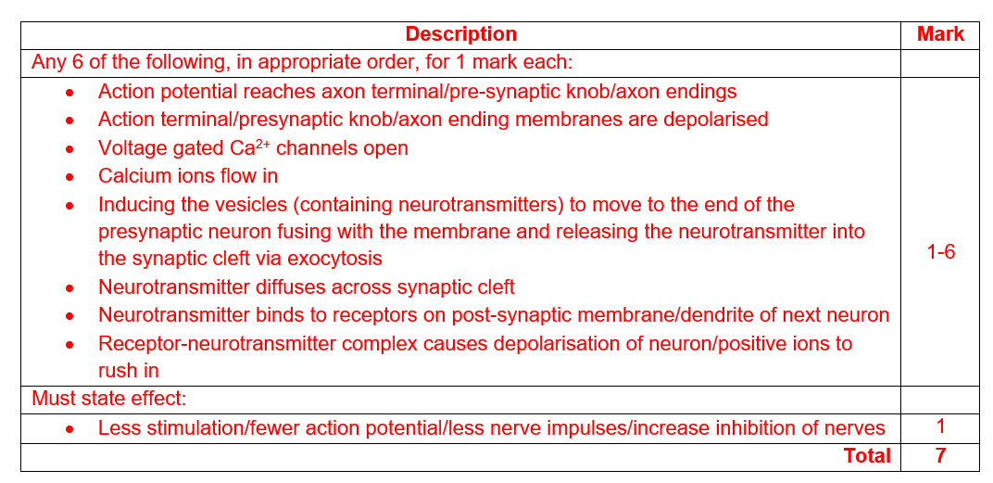

The cause of Huntington’s is a mutation in the HTT gene that produces a protein associated with nerve cells in the brain. The HTT mutation involves a segment of DNA known as CAG trinucleotide repeat. In people with Huntington’s, this segment is repeated at least 36 times.

1. Define the term mutation by describing **both** gene and chromosomal mutations, and identify the **two** cell processes that can result in mutations. (7 marks)

|  |  |
| --- | --- |
| **Description** | **Mark** |
| Random spontaneous changes in DNA/nucleotide sequence/genetic material | 1 |
| (Gene mutation) Two marks from the following: |  |
| * occurs within a single gene * doesn’t involve the whole chromosome * change in one (or few) nucleotide bases * substitution, insertion or deletion of nucleotide bases | 1-2 |
| (Chromosomal mutation) Two marks from the following: |  |
| * all or part of a chromosome is affected * more than one/multiple genes are affected * involves deletions, duplications, inversions, translocations and non-disjunction * usually cause severe abnormalities/multiple phenotypic effects | 1-2 |
| Two of the following for 1 mark each: |  |
| Errors in   * DNA replication, and * cell division/mitosis/anaphase | 1-2 |
| **Total** | **7** |